How to Earn Extra Income from Home in 2026 – Complete Guide for Students and Professionals
Subheading:
Transform Your Skills Into Financial Success Through Technology, Digital Marketing, and Professional Training.

Section 1: Why Skill Development Matters
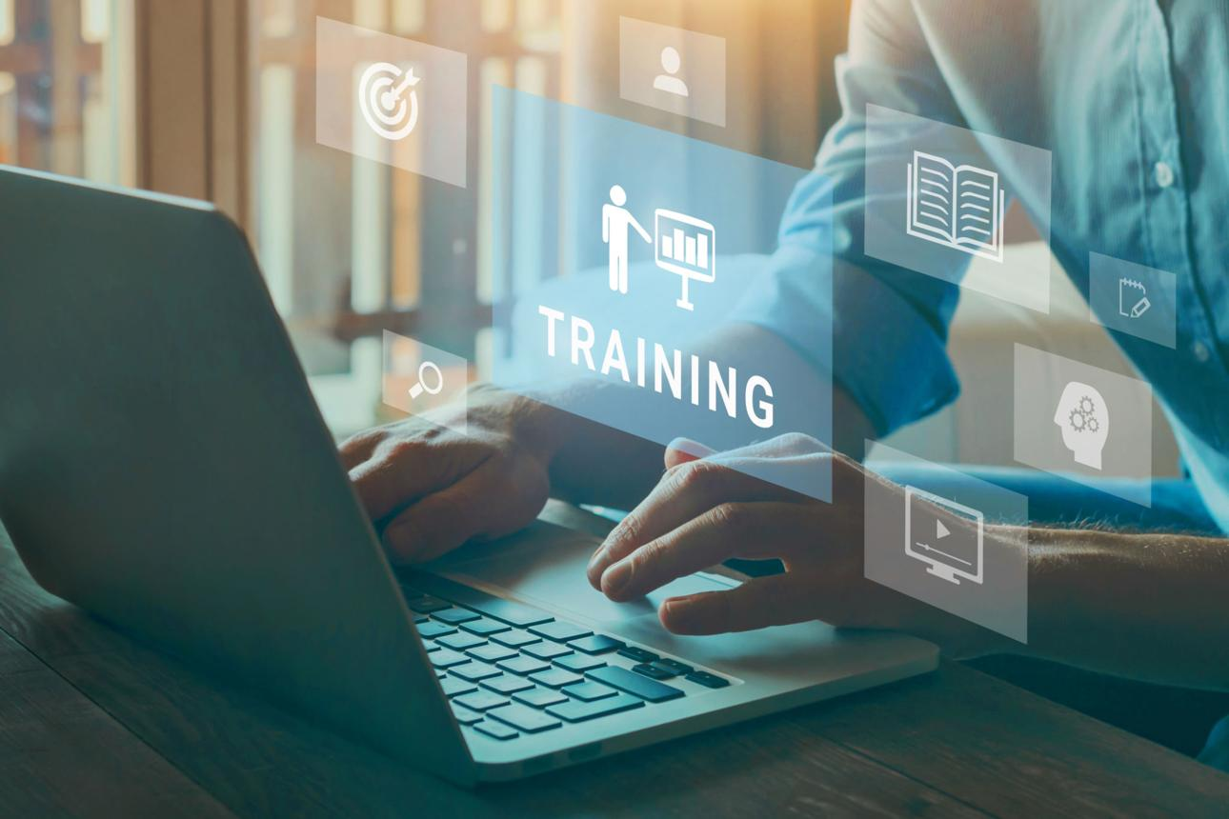
Design Tip:
"Your income can grow only as much as your skills grow."

In today’s competitive world, increasing family income is no longer just a desire—it has become a necessity. Rising living costs, career competition, and changing market demands require individuals to continuously upgrade their skills and explore new income opportunities.
The good news is that the digital revolution has created countless opportunities for students, professionals, entrepreneurs, and job seekers to build additional income streams from the comfort of their homes.
This article provides a practical roadmap to help you develop high-demand skills, attract customers, and create long-term financial growth.

Section 1: Website Development

💡 In the modern business environment, every organization, professional, and entrepreneur needs an online presence.
Website development is one of the most valuable skills in today’s digital marketplace.

Benefits of Learning Website Development
✔ Create websites for businesses, professionals, and organizations.
✔ Earn approximately ₹20,000–₹30,000 or more per month through freelance projects.
✔ Work remotely from home.
✔ Build a sustainable side income or full-time career.
✔ Serve clients locally, nationally, and internationally.
As businesses continue shifting online, the demand for skilled website developers continues to grow rapidly.

Section 2: Video Editing


2. Video Editing – Turn Creativity into Income
Video content dominates social media, marketing campaigns, education platforms, and entertainment industries.
Every day, thousands of videos are created for:
- Weddings and events
- YouTube channels
- Social media marketing
- Business promotions
- Educational content

Why Video Editing Is a Powerful Career Skill
✔ High demand across multiple industries.
✔ Flexible freelance opportunities.
✔ Potential to work with clients globally.
✔ Opportunity to build a creative and rewarding career.
A skilled video editor can generate consistent income while working independently or with organizations.
Section 3: Software Development

Software powers the modern world.
From retail shops and hospitals to educational institutions and multinational corporations, every organization relies on software systems to manage operations efficiently.

Advantages of Learning Software Development
✔ Excellent career opportunities.
✔ High earning potential.
✔ Strong demand in both domestic and international markets.
✔ Opportunity to build your own products and solutions.
✔ Ability to work as a freelancer, entrepreneur, or corporate professional.
If you possess creativity, analytical thinking, and problem-solving abilities, software development can become a highly rewarding profession.

The Secret to Long-Term Income Growth
Success is not built overnight.
Stable and sustainable income growth requires:
- Continuous learning
- Practical experience
- Consistent effort
- Professional guidance
- Strong work ethics
Technology continues to evolve, and individuals who continuously upgrade their knowledge remain ahead in the job market and business world.
Remember:
Skills create opportunities. Opportunities create income. Income creates financial freedom.

4.How to Get Customers After Learning These Skills
One of the most common questions people ask is:

“After learning these skills, how do I find customers?”
The answer is simple:
Customers are everywhere in the digital world.
The challenge is not finding customers—the challenge is making customers aware of your services.

Build Your Personal Brand
Today’s successful professionals actively showcase their skills online.
You can create a strong digital presence by:
- Sharing your work portfolio
- Posting project samples
- Creating educational content
- Publishing success stories
- Demonstrating your expertise
A strong online reputation builds trust and attracts potential clients.

The Power of Social Media Marketing
Millions of people spend hours every day on social media platforms



Digital Marketing: Your Gateway to Global Opportunities
Digital marketing is one of the most effective methods for promoting products and services in today’s business environment.
Unlike traditional marketing, digital marketing enables you to reach targeted audiences at a lower cost and achieve measurable results.

Benefits of Digital Marketing
✔ Reach customers worldwide.
✔ Promote your services 24/7.
✔ Generate quality business leads.
✔ Build brand awareness.
✔ Increase sales and revenue.
✔ Create multiple income streams.
By combining technical skills with digital marketing knowledge, you can significantly increase your chances of long-term success.

Conclusion: Invest in Learning, Invest in Your Future
The future belongs to individuals who are willing to learn, adapt, and grow.
Whether you choose website development, video editing, software development, or digital marketing, the key is to start learning today and continuously improve your expertise.
Knowledge is not an expense—it is an investment.
The skills you develop today can create opportunities, increase your income, and provide a better future for you and your family.

Remember
Learning today is an investment that creates tomorrow’s success.
Upgrade your skills. Build your confidence. Create opportunities. Increase your income.

About the Author

Birupaksha Lodh, MCA, PGDCS
Founder & IT Professional

Swami Vivekananda Technology
A Complete IT Solutions Provider
Services:
- Website Development
- Software Development
- Digital Marketing
- IT Training
- Technical Consultancy
Website: birulodh.in
Mobile: +91 9862071009
“Empowering Individuals Through Technology and Skill Developme

